3 Days 2 Nights Kuching Free & Easy Package
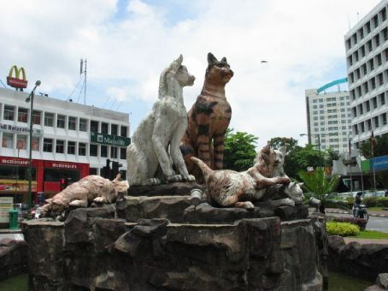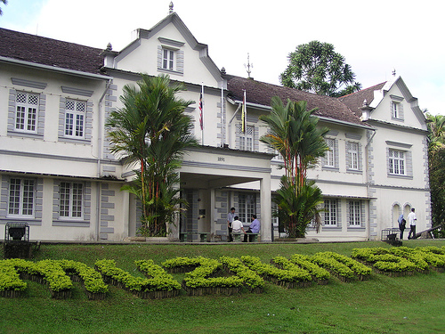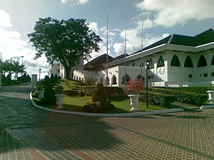

Package Rate per pax (RM)  Room based on R.O.H. |  | 2 - 3 pax  ~ seat-in-coach ~ |  | 4 – 7 pax  ~ seat-in-coach ~
 |  | Twin/Triple | Single | Twin/Triple | Single
3* Kuching Park / Kingwood Inn |  | 260.00 | 385.00 | 235.00 | 360.00
3* Harbour View / Grand Continental |  | 280.00 | 425.00 | 255.00 | 400.00
4* Grand Margherita Hotel |  | 355.00 | 575.00 | 330.00 | 550.00
4* Damai Beach Resort |  | 375.00 | 575.00 | 330.00 | 530.00
5* Hilton Kuching |  | 420.00 | 705.00 | 395.00 | 680.00
5* Pullman Kuching |  | 425.00 | 715.00 | 400.00 | 690.00
~ Child with ½ share twin room @ 90% of adult rate.
~ Child with extra bed @ 80% of adult rate.
~ Child without bed @ 60% of adult rate
PACKAGE INCLUDES : | ~ 2 Night accommodation at City Hotel / Resort of your choicewith daily breakfast.  ~ Guided Kuching City & Shopping Tour (All guided tours are included of entrance fee)  ~ Airport – Hotel / Resort – Aiprort Return Transfer.  ~ Experienced English / Mandarin / B.M. speaking guide. (RQ before arrival)
PACKAGE EXCLUDED : | ~ Airfare & Airport Taxes.  ~ Suggested Tipping for guide/driver @ min RM 5.00 per pax per day.  ~ Optional Tour.  ~ Travel Insurance & Personal MISC Expenses.  ~ Peak Season Surcharge during New Year Day, Chinese New Year, Labour Day, Hari Gawai,  RWMF, National Day, Hari Raya, Christmas Day, July. 01-02 Jan 12 , 22-25 Jan 12

Itinerary :
Day 01 ARRIVAL KUCHING
Meet arrival, proceed to City Tour : Ornate Chinese Temples, The Astana, City Tower,
Sarawak Museum, Cat Museum, Cat Monument, Market, Main Bazaar, China Town,
Old State Mosque, KEK LAPIS STORE. After Tour transfer to Hotel for check in
Free at own leisure

Day 02 KUCHING (B)
Hotel breakfast, free at own leisure or join optional tour
( S.O.T. : Sarawak Cultural Village / Bako National Park / Semenggoh Orang Utan and etc )
Free at own leisure

Day 03 DEPARTURE – KUCHING AIRPORT (B)
Hotel breakfast, free at own leisure until transfer to Airport for flight departure

Notes :
- The above rate are subject to acceptance of resort’s term & conditions of contracts.
- The Hotel reserves all rights to revise the contracted rates without prior notice.
- Validity : Until 31 March 2012.
- All rate quoted is base on RINGGIT MALAYSIA

